# Design, Simulation and Implementation of “*SELF BALANCING ROBOT*” using ARM based Cortex FRZ-KL25Z Microcontroller

*1*Horia Petre, student of MEng. ECE, Concordia University, *2*Diego Mayorga, student of MEng. ECE, Concordia University, *3*Md. Shafayet Sajid, student of MEng. ECE, Concordia University.

## *Abstract – This project uses the ARM Cortex Microcontroller FRZ-KL25Z to balance a structure with the help of a Proportional, Integral and Derivative (PID) algorithm which drives two motors with wheels in response to a signal from an Inertial Measurement Unit (IMU). The Microcontroller was programmed to control the error signal between the angle sensed by the IMU and a desired vertical angle. This error is passed through a PID controller to send a command to the motors, to keep the structure balanced.*

***Index Terms – Microcontroller, Self-Balancing, PID, Motor Drive, Robot.***

## INTRODUCTION

**M**icrocontrollers play an important role in electronics fields both in home and business applications. It is not only reducing the design complexity but also introduces a new era in Control System design. In this project we tried to program an ARM based Cortex Microcontroller (Model: FRZ-KL25Z) which is very cost effective. The project aim was to control a robot with two wheels that can self-balance. Design of the circuit, solutions to mathematical equations, writing of codes and simulation in ARM complier were the approaches taken to try to solve this project. The main challenge of the project was to stabilize the vertical angle of the robot using PID control logic. Following are the detailed steps that we took to finalize the project.

## DESIGN COMPONENTS

### i) FRZ-KL25Z Microcontroller, ii) L298N motor drive module, iii) two geared DC motor with wheel, iv) Frame board coupled with motor wheel, v) Bread board, vi) Jumper wires, vii) One no. 9V and four nos. AA rechargeable battery, viii) Wave-100 10 DOF IMU sensor, ix) Bluetooth Module.

## EXPERIMENT & DESIGN

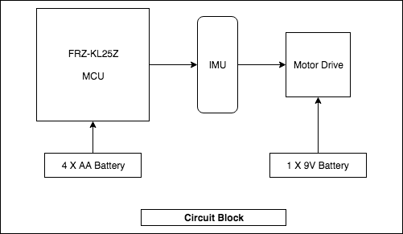

We designed the circuit in such a way that the MCU processed the output of IMU and compared it to a desired angle from the vertical position, thus giving an error which is sent to the Motor Drive module as a Pulse Width Modulation command to drive the motors and thus balance the two-wheeled frame body.

This experiment used the PID controller as per the equation below, where Kp is the proportional gain applied to the current error, Kd is the derivative gain applied to future error and Ki is the integral gain applied to past errors.

$$u\left(t\right)=Kp*e\left(t\right)+Kd*\frac{d}{dt}e(t)+Ki*\left(e\left(t\right)\right)$$

1. *MCU: FRZ-KL25Z*

The Microcontroller that we used is very popular in ARM Cortex Family and it is widely used. It is compact in design with lot of built in integrated features such as 32-bit fast I/O access port, 128 KB flash memory, DMA Controller, Voltage regulator, clocks, 12 bit DAC, PWM module, Accelerometer etc. We powered the board with 4 nos. AA batteries and we designed a common ground so that no value is floated in the circuit.

1. *IMU: 10 DOF (Degrees of Freedom)*

In the circuit, we utilized the MPU 9255 IMU as a main sensor. It is a composed of an accelerometer, gyroscope, pressure meter and magnetic compass, although the last 2 features are not used in this project It measures and reports orientation, velocity and gravitational forces through accelerometer and gyroscopes. It combines the readings of the gyro and of the accelerometer through the equation

$$Angle = 0.98 * (Angle + gyroAngle) + 0.02f * accAngle$$

The IMU has to combine the gyro and accelerometer readings because the accelerometer will give false readings if the structure is moving and thus it needs the gyro to give a more accurate reading of the angle.

1. *Motor Drive Module (L298N)*

### We have used a dual (H-bridge) bidirectional motor driver in the circuit as it can easily and independently control two motors of up to 2A each in both directions. It has also a heat sink and can handle up to 35V. We powered this module through a 9V battery. There are three inputs per motor to the module, a Pulse Width Modulation command for the speed, and two inputs giving the direction in which the motor tuns. There are two output pins per motor connected to their respective motor.

### *Bluetooth Module*

### We have also used a Bluetooth module to control the robot remotely. We have developed a mobile application so that we can control the direction and speed from a mobile device.

1. *Control Method*

Our main function executes based on the popular control theory PID technique where Kp, Ki and Kd are the gain which are compared to previously set values as reference.

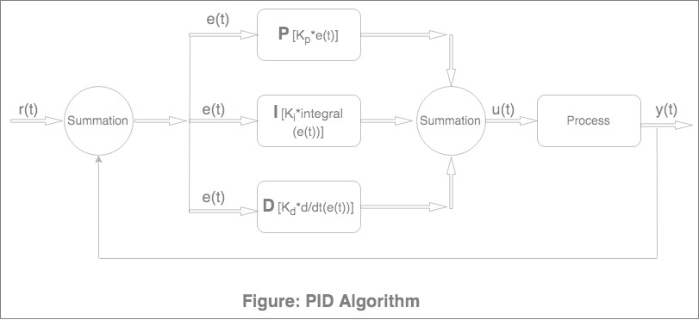

This controller compares IMU angle values to a desired angle and outputs a command based on gains Kp, Ki, Kd.

1. *Power Management*

We have used one 9V battery to power the motors and four AA batteries in series which can supply the power to the FRDM-KL25Z board. Each battery is 1.5V so we were getting 6V nominal voltage at its full charged state. We used Vin PIN of the I/O headers (J9 pin 16) which can take voltage 4.3 - 9 V (as per data sheet) grounding in PIN 14. Typical discharge characteristics is shown below:

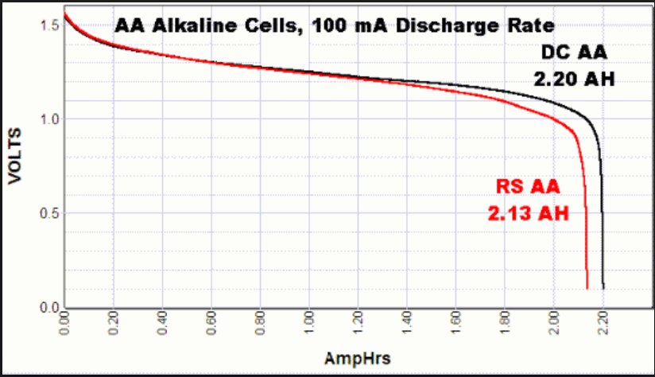

We created a common ground for the board, the motor controller, the imu and the Bluetooth module.

We powered the IMU and Bluetooth modules from PIN 3.3 V of the board.

## RESULTS

The Microcontroller has its own compiler and we coded with the language C for ARM based MCU. Following topology of coding were used for the complete operation:

1. MCU Control
2. IMU Control
3. PID Control
4. Motor Control

*Results*

The PID control system was simulated in Simulink/Matlab as shown below

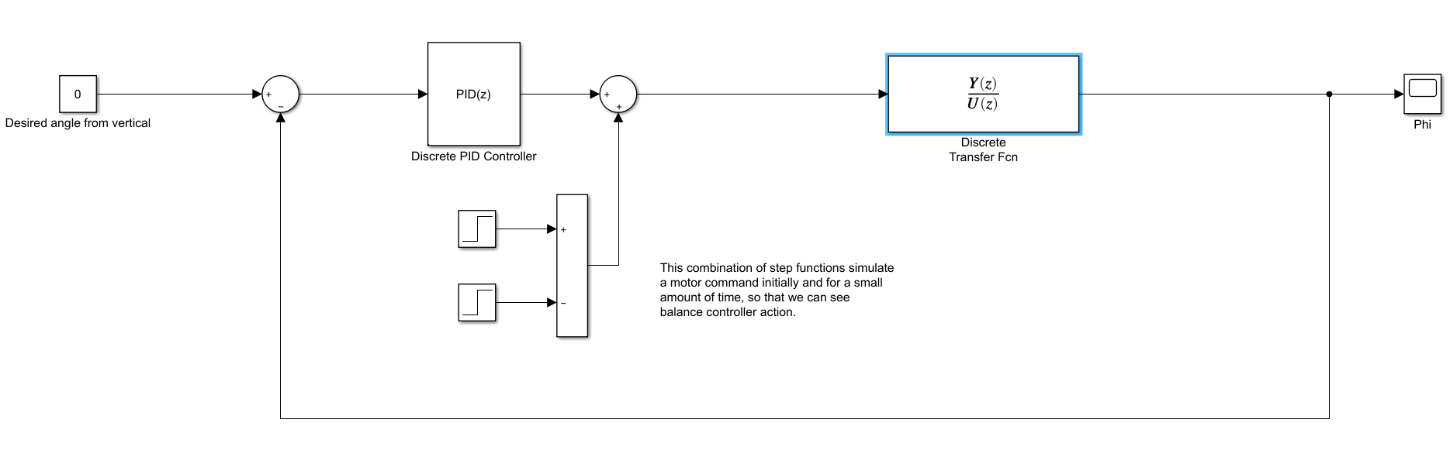

In the diagram, the parameters are as follow

|  |  |
| --- | --- |
| M, mass of base cart including motors (kg) | 0.5 |
| m, mass of structure (kg) | 0.3 |
| L, height of structure (m) | 0.3 |
| B, friction of the cart (N/m*s) | 0.1 |
| I, inertia of the pendulum system (kg*m2) | 0.006 |
| G, acceleration due to gravity (m/s2) | 9.8 |

Plugging the above parameters in the transfer function equation,

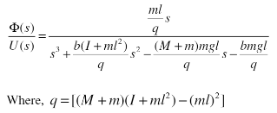

thus giving a transfer function in s-domain

$$\frac{phi}{u}=\frac{4.918 s}{s^3 + 0.1803 s^2 - 38.56 s - 4.82}$$

This transfer function is discretized with a sampling period of 0.01s (10ms) to accommodate the iteration rate of the KL25Z thus giving a transfer function in the z-domain

$$\frac{phi}{u}=\frac{0.0002458 z^2 - 1.477e-07 z - 0.0002457}{z^3 - 3.002 z^2 + 3 z - 0.9982}$$

Furthermore, the Kp, Ki and Kd control gains are found using matlab to be 24, 39 and 3 respectively.

Applying a step input to the system gives the following response

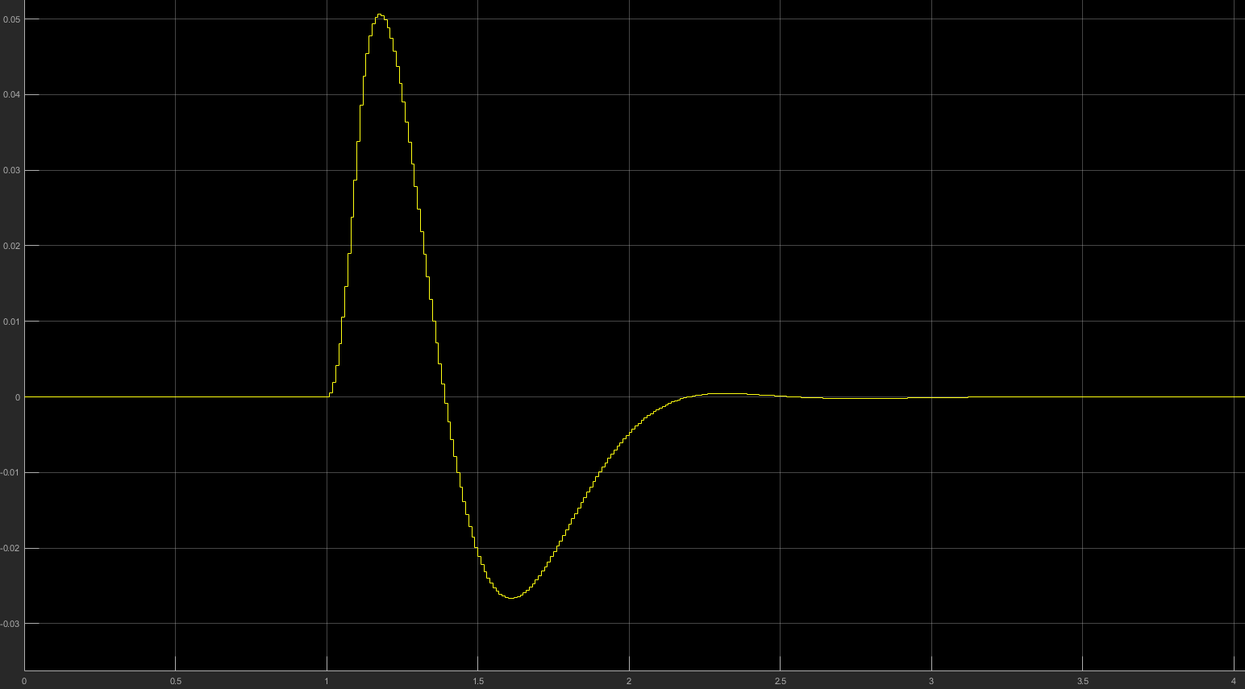

The controller moves the motors to bring the angle from the vertical to zero in about 2.6 seconds. The simulation in Simulink/Matlab gives promising results as it shows that the robot can be balanced by this PID control system.

In reality thought, the physical structure is not stabilized and it fluctuates back and forth and after some time, even falls. This could be due to the motors being underpowered, that is a single 9V battery is not sufficient to drive them both under heavy load. Such heavy load is required when the structure angle is pronounced and the rate of change of the angle from the vertical is high. In that case the Derivative term of the control system sends a high command to the motors but since they are underpowered, they do not respond with force.

Another possibility that would make the physical structure unstable is the backlash in the motor gearings. That is, each gearbox has a backlash of about 0.4 degrees where the wheel moves, but the motor does not. It is well known that a system with considerable backlash can be hardly controlled, if at all.

To conclude, we used the microcontroller KL25Z to balance a vertical structure. The control system used the KL25Z to run the control logic, an Inertial Measurement Unit, composed of an accelerometer and a gyroscope that gives the angle from the vertical of the structure, a motor controller and a Bluetooth module. We simulated a simplified system with Matlab/Simulink which seemed to work. But when we tried to implement the control system on actual hardware, we found that the structure was not easily balanced for reasons going from underpowered motors to gearbox backlash.

*References*

https://github.com/hpetre/COEN-6711

https://www.researchgate.net/publication/236030928_Autonomous_Dual_Wheel_Self_Balancing_Robot_Based_on _Microcontroller

https://www.semanticscholar.org/paper/Design-and-control-of-a-two-wheel-self-balancing-JuangLum/2dad074eed5019eb2b1e3056bbd9b82442ec596a

https://www.idosi.org/mejsr/mejsr25(4)17/19.pdf 5. M. Hasan, C. Saha, M. Rahman, R. I. Sarker, S. K. Aditya. Balancing of an Inverted Pendulum Using PD Controller. Dhaka Univ. J. Sci. 60(1): 115-120, 2012